**MULE WORKSPACE SETUP**

1. Anypoint Studio

Download AnypointStudio from below link.

\\livpvnasci01\share\eStart Support Team\Next Generation eStart\Software\AnypointStudio\AnypointStudio.zip

Please update the jdk path in AnypointStudio.ini file

Use the AnypointStudio.exe file to launch.

1. Maven Plugin

Download Maven plugin from below link.

\\livpvnasci01\share\eStart Support Team\Next Generation eStart\Software\apache-maven-3.5.4-bin.zip

1. Mule GitHub Packages

|  |  |
| --- | --- |
| Artifact Name | Mule Github Repo |
| NGE mulesoft domain | *hip1-nge-domain* |
| Coexistence layer shared java library | *nge-us-legacy-coexistutil (jar)* |
| Legacy submission utility web service | *nge-us-legacy-submissionutil* |
| Submission web service | *nge-us-submission* |
| XML Emulation Gateway | *nge-us-xmlemulationgateway* |
| Submission Status service | *nge-us-submissionstatus* |
| Legacy submission status util service | *nge-us-legacy-submissionstatusutil* |
| Submission status BPEL Process | *nge-us-submissionstatus-process* |
| Account Service | *nge-us-account* |
| Diary Service | *nge-us-diary* |
| Producer Service | *nge-us-producer* |
| Reservation Helper Service | *nge-us-reservationhelper* |
| User Service | *nge-us-user* |
| MF Emulation Gateway | *nge-us-mfemulation* |
| Mainframe Services | *nge-us-mainframe* |
| MF Emulation Util | *nge-us-legacy-mainframeutil* |
| Submission Data Service | *nge-us-submissiondata* |
| Submission Management Service | *nge-us-submissionmanagement* |

1. Maven Plugin set up

Window 🡪Preferences🡪Maven

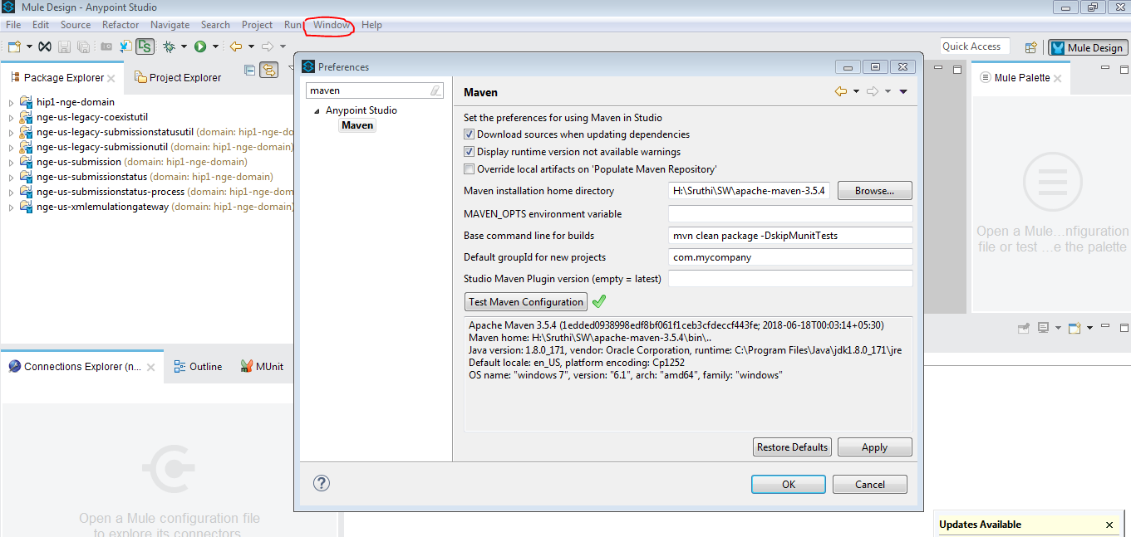

1. Add below variables as system envirnonment variables

M2_HOME=Path of your local maven install (E.g.C:\apache-maven-3.5.4)

M2=%M2_HOME%\bin

MAVEN_OPTS=-Xms256m -Xmx512m

PATH=%M2%

1. Update JRE to 1.8

Window 🡪Preferences🡪Installed JREs

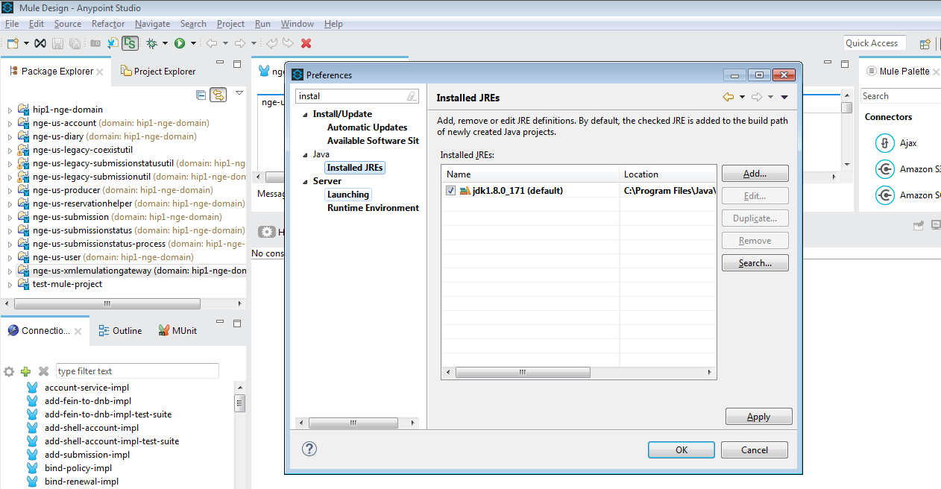

Update the path in AnypointStudio.ini (..\AnypointStudio\AnypointStudio.ini)

1. Importing From GitHub Repository to Anypoint Studio

Follow the below link to install the Git Plugin and import the project using github source URI.

* <https://confluence.aig.net:8443/display/CI/Importing+From+GitHub+Repository+to+Anypoint+Studio>

**Or follow the below steps to import project via pom.xml**

* Download the packages from Git Hub and import the packages to workspace manualy.

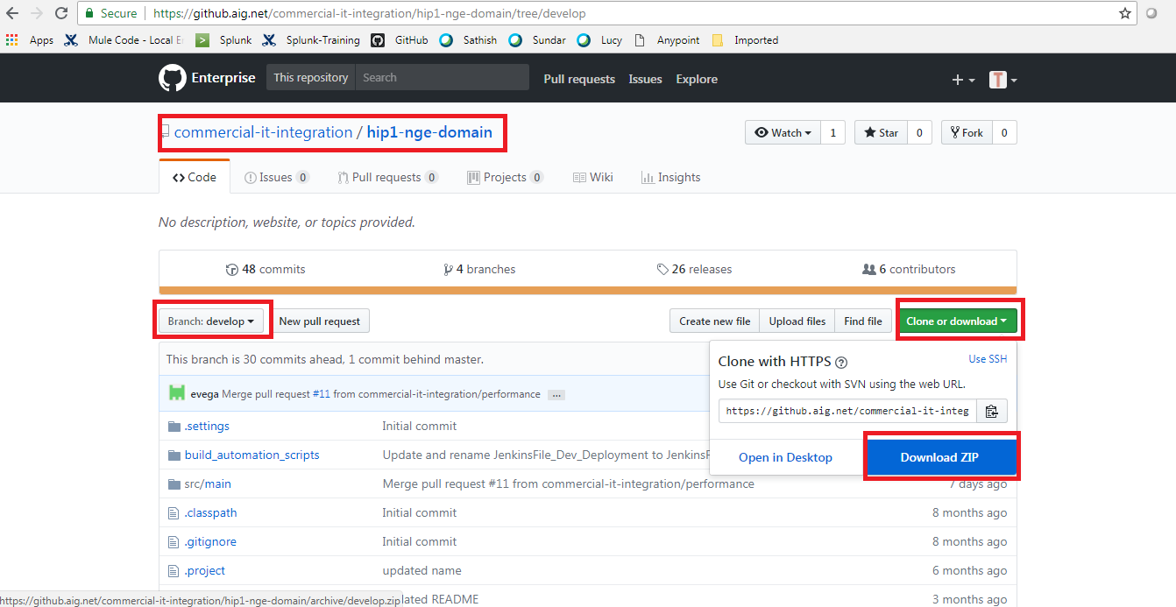

Importing Packages to Workspace

* Extract the packages downloaded from git hub.
* Import 🡪 Maven Based Mule Project from Pom.xml🡪Next

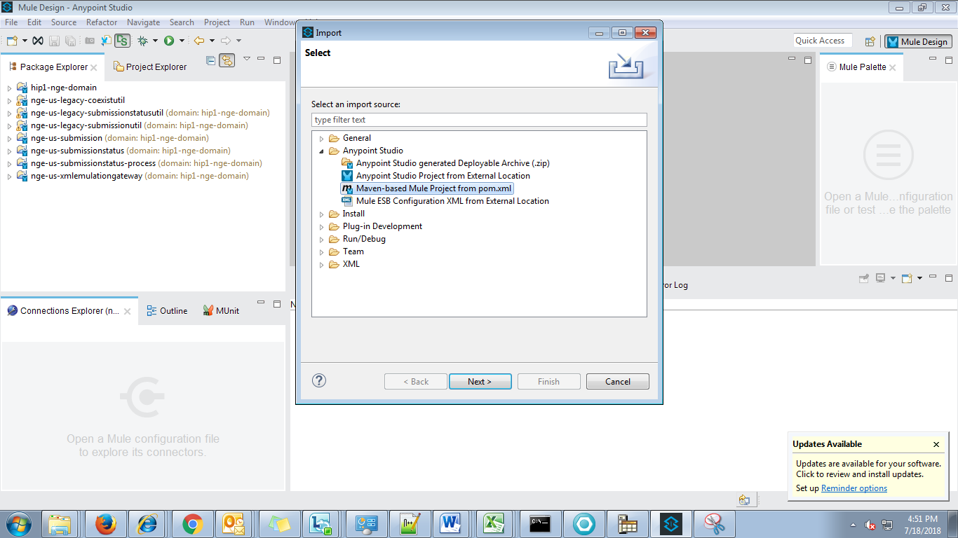

* Browse Pom.xml file for each package 🡪 Finish

(..\nge-us-diary-develop\nge-us-diary-develop\pom.xml)

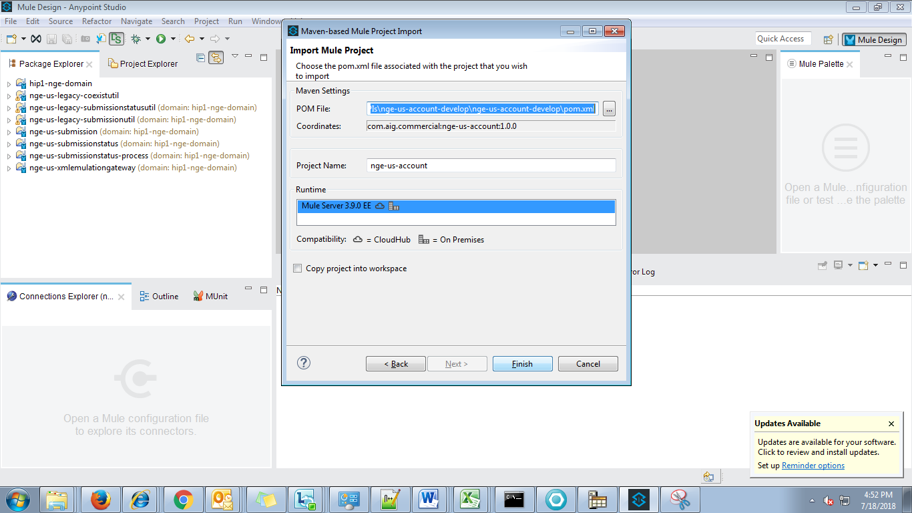

1. Settings.xml

* Download the settings.xml using the confluence link - <https://confluence.aig.net:8443/display/CI/Artifactory+-+Binary+Repository>
* Copy the settings.xml into below 2 directories
* Click window + R and type m2 and enter and paste setting.xml or m2 repo folder (E.g.C:\svalappi\.m2)
* Go to maven installed directory and paste setting.xml

..\apache-maven-3.5.4\conf



1. Updating maven dependency.

Project 🡪 Right Click 🡪 Mule 🡪 Update Project Dependencies

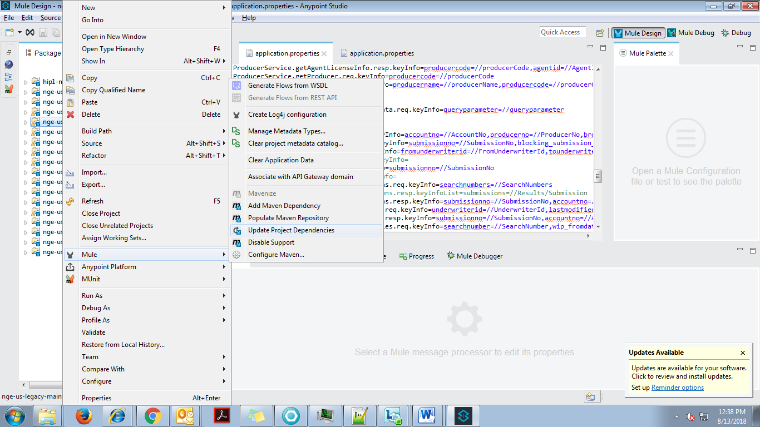

1. Update the tls-default.conf under ..\AnypointStudio\plugins\org.mule.tooling.server.3.9.0.ee_6.4.1.201710111930\mule\conf.

**enabledProtocols=TLSv1,TLSv1.1,TLSv1.2** (edit both the files)

Or

Copy & paste below two files in anypoint studio installation path.

..\AnypointStudio\plugins\org.mule.tooling.server.3.9.0.ee_6.4.1.201710111930\mule\conf.



1. Copy Jackson 12 library jars into anypoint studio path

**Source:** AnypointStudio\plugins\org.mule.tooling.server.3.9.0.ee_6.4.2.201712051241\mule\lib\opt

**Destination:**

AnypointStudio\plugins\org.mule.tooling.server.3.9.0.ee_6.4.2.201712051241\mule\lib\boot

Or

Copy & paste below 12 library jars to below path

AnypointStudio\plugins\org.mule.tooling.server.3.9.0.ee_6.4.2.201712051241\mule\lib\boot

|  |
| --- |
|  |

1. Open command prompt as Administrator and configure the certificates using keytool commands as defined at below URL:

<http://confluence.aig.net:8090/display/CI/Certs+for+Developers>

* SSL Configurations

Run the below InstalCert.java file and commands in the below format.



**E.g. Currency Conversion Proxy**

* java InstallCert dev.hip1.aig.net:32000
* keytool -exportcert -alias dev.hip1.aig.net-1 -keystore jssecacerts -storepass changeit -file ccsproxy_url.cer
* keytool -importcert -alias dev.hip1.aig.net-1 -keystore "C:\Program Files\Java\jdk1.8.0_171\jre\lib\security\cacerts" -storepass changeit -file ccsproxy_url.cer
* keytool -importcert -alias dev.hip1.aig.net-1 -keystore "C:\Program Files\Java\jre1.8.0_171\lib\security\cacerts" -storepass changeit -file ccsproxy_url.cer

1. Updating URLs to run in local set up

Update the url in app-config-dev.properties file of respective project as given below.

E.g. *nge-us-xmlemulationgateway*

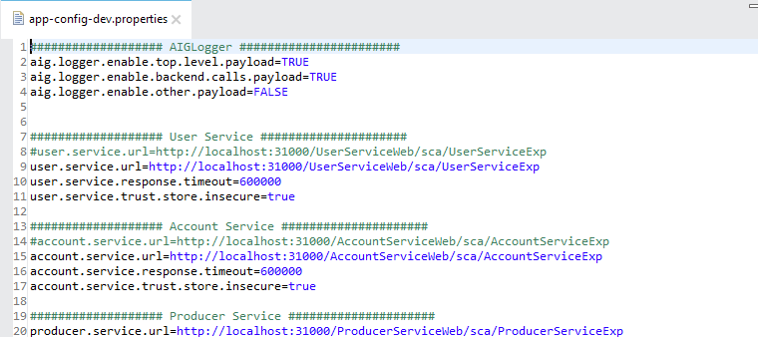

1. Create keyfile.properties file under C:/Temp/Props (or any other folder) and enter below values in the file:

**vault.key=Synergy123456789**

**or**

**Paste below file in C:/Temp/Props**



1. Run the app with the following vm Settings in VM arguments.

Right click the project checkout (nge-us-mfemulation) and

Run🡪 Run Configurations ->click arguments

**-XX:PermSize=128M -XX:MaxPermSize=256M -DskipTests -Dmule.env=local -Dmule.propertiesFolder=C:/Temp/Props**

**(Above highlighted folder and folder used in step 14 should be same)**

Click 🡪Apply

**Note:** Make sure to provide the forward slash (/) in argument Dmule.propertiesFolder

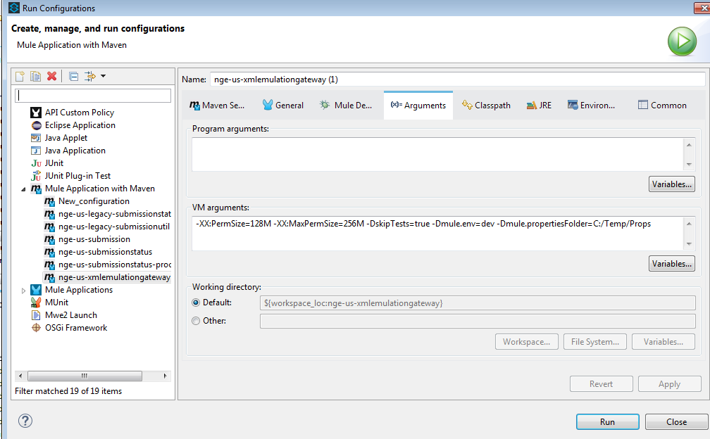

**Click maven setting**

**-DskipTests=true**

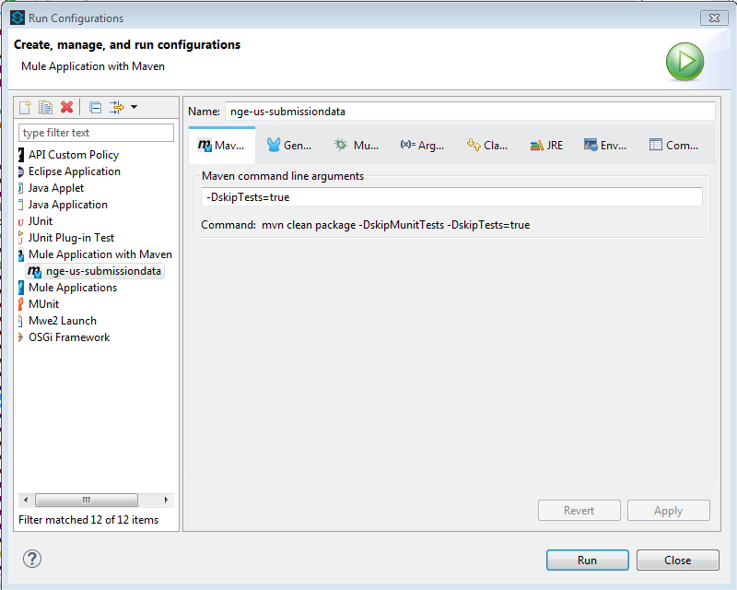

**Choose projects want to run**

**Click general->and choose project**

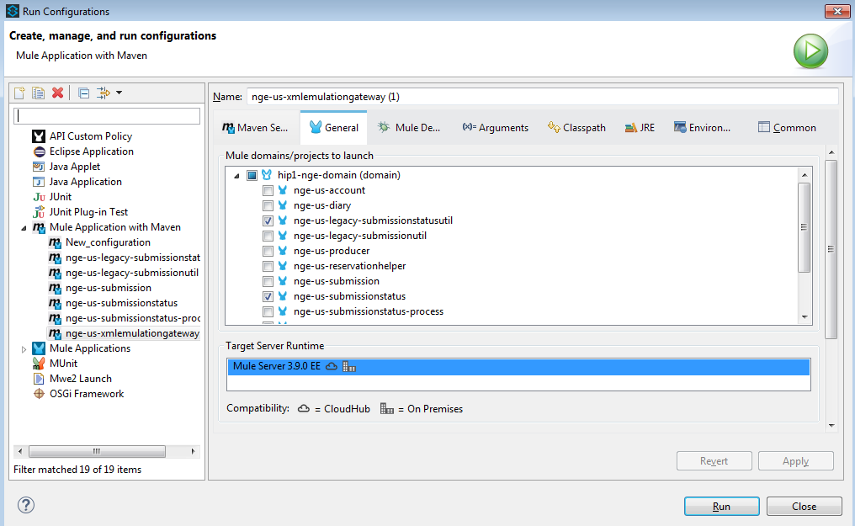

Click 🡪 Run.

1. Mule Workspace Setup Instructions

Make sure to follow the instructions in the below link.

<https://confluence.aig.net:8443/display/CI/Mule+Code+-+Local+Env+setup+and+Deploy+Instructions>

1. Mule Documentations

\\livpvnasci01\share\eStart Support Team\Next Generation eStart\MuleSoft conversion from WPS\Documents\

<https://confluence.aig.net:8443/display/CI/NGE+KT+Sessions>

1. Non Issues

